HAV
Student’s Name
Intuition
Lecturer
Date

Introduction
Hepatitis A virus (HAV) is a non-enveloped hepatotropic virus classified in the Hepatovirus genus in the family of Picornaviridae. HAV has been known for causing a liver infection that is rarely fatal. HAV infection is more frequently seen in developing countries, especially in children as HAV is transmitted through contaminated food and drink [4]. Hepatitis A does not cause long term illnesses like Hepatitis B and C; hence infected people can recover fully. The best way to prevent HAV infection is by vaccination. I have always been interested in learning the hepatitis virus in all its types A, B, C, D, and E. I found this to be a great opportunity to learn more about HAV.
The picture blow shows HAV
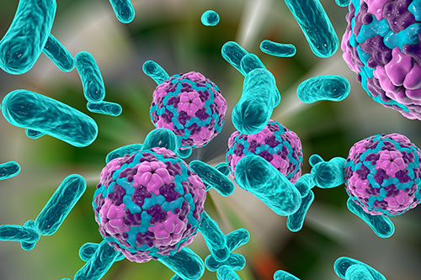

Transmission
Hepatitis A virus gets transmitted from one person to another through the faecal-oral process when a person ingests food or water contaminated by faeces. Human waste of a person infected by hepatitis A virus forms the main breeding of the hepatitis A virus. The hepatitis virus exists within the contaminated materials within the environment. Proper hand washing is the main method of prevention of HAV transmission. Close physical contact with contaminated surfaces or infected people can lead to the spread of HAV. Activities such as anal and oral sex can lead to the spread of the hepatitis A virus.
Prevention and Vaccination
Vaccination needs to be considered a comprehensive plan for preventing and controlling hepatitis A form getting viral. Planning for robust immunization programs needs to involve careful economic evaluations and use additional prevention methods. The methods of avoiding the hepatitis A virus include improved sanitation and hygiene practices. The process of conducting child immunizations must get developed to reduce the future occurrence of the hepatitis A virus.
Most countries have developed hepatitis A immunization schedules that are significant in health outcomes.. The use of the vaccine got recommended for people who were at risk of hepatitis A. The people include the users of recreational drugs and travelers to countries where the virus is endemic. The creation of the feasibility of implementing widespread immunization campaigns must get included in the plan. Everybody would know about understanding the need for creating hygiene. Creation of campaigns would champion for increasing immunization processes within states. processes at any level. HIV infected people with low CD4 counts need to get a higher dose of two shots of the vaccine. To get fully protected, everybody must understand the two shots of HAV vaccination. The people living with HIV must get vaccinated when they travel to areas with high Hepatitis A. Lastly, an injection of immune globulin can help prevent HAV infection to people who never got vaccinated. Post-exposure prophylaxis provides short term protection against disease that may get developed by Hepatitis A virus. Immune globulin can get administered to people after two weeks of exposure to the Hepatitis A virus. The vaccine is crucial in preventing the occurrence of hepatitis A in the lives of people. People above 40 years can use either immune globulin or hepatitis A vaccine after getting exposed to the virus.
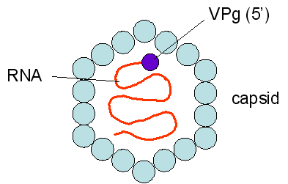THE STRUCTURE OF HAV

Diagnosis and Treatment
Doctors typically perform blood tests for antibodies to ensure anybody infected with hepatitis A gets diagnosed. The incubation period for HAV ranges from 15 to 50 days [2]. The infected people can spread the virus to others within this period hence the need for diagnosis. The incubation period gets shorter as people become older. Carrying out blood tests on antibodies allow HAV to get diagnosed in the body of infected people [1]. There are signs of hepatitis A that gets recorded during testing. They include loss of appetite, vomiting, fatigue, nausea, dark-coloured urine, and fever. Some people do not show symptoms at all, with only flu getting observed. No treatment of hepatitis A virus does exist, but rest and proper nutrition can reduce its symptoms. Supportive care and tests help make the immune system of patients reduce the increase of hepatitis A infection. People can take two months to recover, but some can take up to six months. The infected patients must stay away from alcohol and medications that may affect the liver. The use of alcohol tends to affect the liver's performance, hence leading to severe problems within the body. Hepatitis A virus affects the mass of people using alcohol while in their sickness mode.
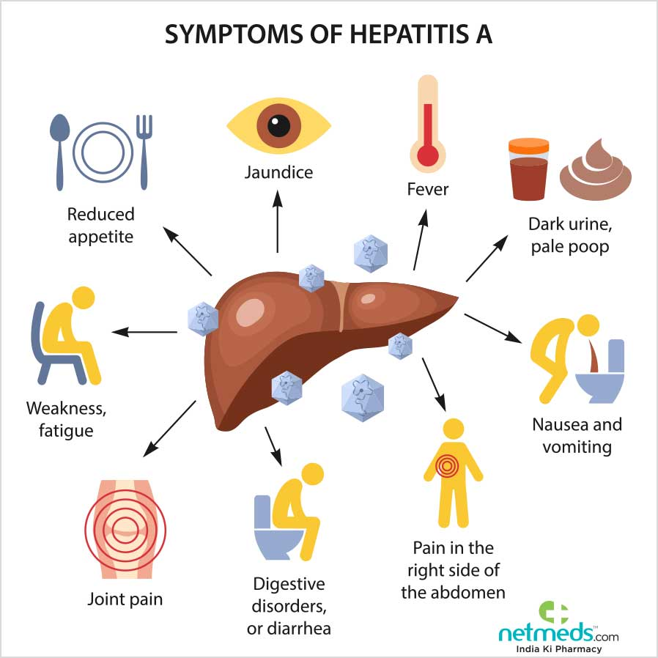

Conclusion
In conclusion, the hepatitis A virus poses a serious health concern in areas where people live. Contaminated sewage materials need to get gathered and disposed of properly to ensure increased sanitation levels. Hygiene needs to get improved to allow for the reduction of transmission of hepatitis A virus amongst people. The creation of productive immunization and vaccination efforts has led to an enhanced state of hepatitis A prevention. People have an opportunity of eliminating the transmission of HAV in their lives after getting vaccinated. Children can get immunized in the process of contacting the disease from the environment. Robust immunization efforts perform appropriate procedures in achieving a high number of people free from the hepatitis A virus.

References
1. Alavi, A., French, L., Davis, M., Brassard, A., & Kirsner, R. 2017. Pyoderma Gangrenosum: An Update on Pathophysiology, Diagnosis and Treatment. American Journal of Clinical Dermatology. Accessed 17 July 2020. <https://doi-org.libproxy.eku.edu/10.1007/s40257-017-0251-7>
2. Centres for Disease Control and Prevention. 2019. Hepatitis A. Accessed 17 July 2020. <https://www.cdc.gov/vaccines/pubs/pinkbook/hepa.html>
3. EASL 2017 Clinical Practice Guidelines on the management of hepatitis B virus infection. 2017. Journal of Hepatology. European Association for The Study of The Liver. Accessed 17 July 2020. < https://doi-org.libproxy.eku.edu/10.1016/j.jhep.2017.03.021>
4. Hasosah, M., Althobaiti, K., Ghandourah, H., & Al-Amir, S., 2011. Acute hepatitis a virus (HAV) infection associated with acalculous cholecystitis. Journal of Pediatric Infectious Diseases accessed 11 July 2020. <https://search-ebscohost-com.libproxy.eku.edu/login.aspx?direct=true&AuthType=ip&db=asn&AN=66691999&site=ehost-live&scope=site>
5. Murthy, N., Rodgers, L., Pabst, L., Fiebelkorn, A. P., & Ng, T. 2017. Progress in Childhood Vaccination Data in Immunization Information Systems. MMWR: Morbidity & Mortality Weekly Report. Accessed 17 July 2020. <https://doi-org.libproxy.eku.edu/10.15585/mmwr.mm6643a4>
6. World Health Organization. 2015. Hepatitis A. accessed 15 July 2020. <https://www.who.int/immunization/diseases/hepatitisA/en/>
7. Redirect notice. (n.d.). Google. https://www.google.com/url?sa=i&url=https%3A%2F%2Fwww.alamy.com%2Fstock-photo%2Fhepatitis-a-virus.html&psig=AOvVaw2_JkRZ0mD8bpRyvGd2fhN7&ust=1596792000356000&source=images&cd=vfe&ved=0CA0QjhxqFwoTCKj5svGfhusCFQAAAAAdAAAAABAD
8. Redirect notice. (n.d.). Google. https://www.google.com/url?sa=i&url=http%3A%2F%2Fwww.medical-labs.net%2Fhepatitis-a-virus-hav-structure-2263%2F&psig=AOvVaw2_JkRZ0mD8bpRyvGd2fhN7&ust=1596792000356000&source=images&cd=vfe&ved=0CA0QjhxqFwoTCKj5svGfhusCFQAAAAAdAAAAABAJ

